JOSHUA EVIOTA IT26B

**INSERT AND SELECT**

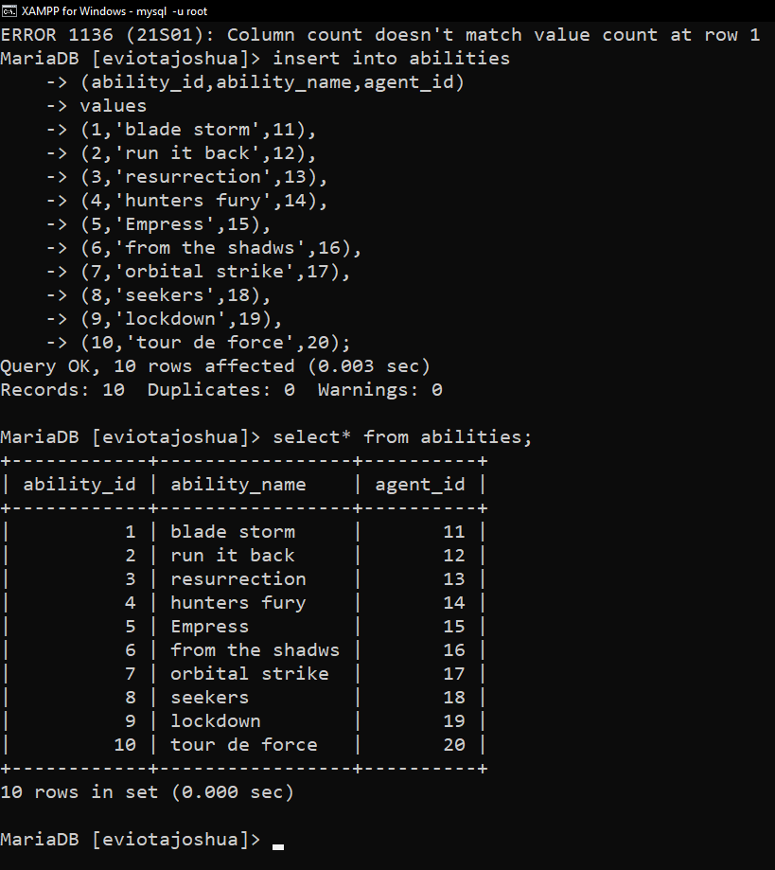

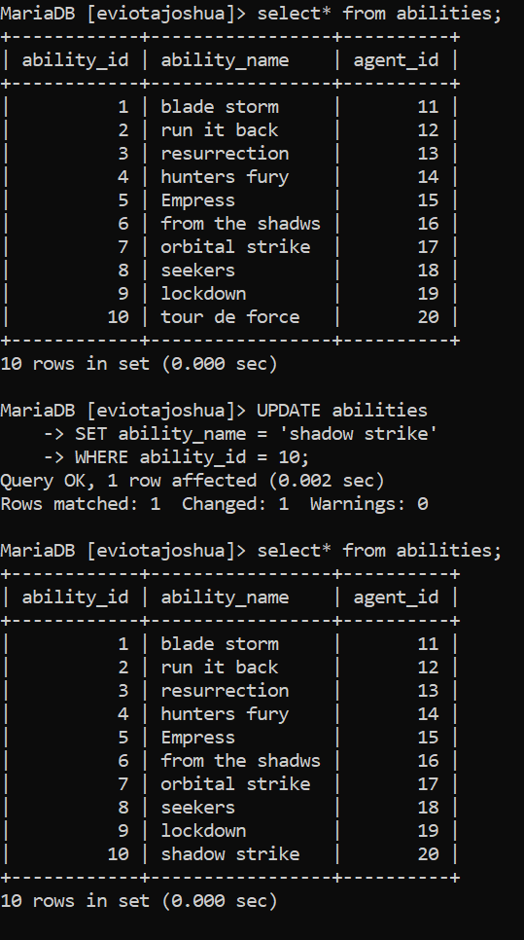  **UPDATE** I UPDATE THE ABILITY_ID 10

DELETE

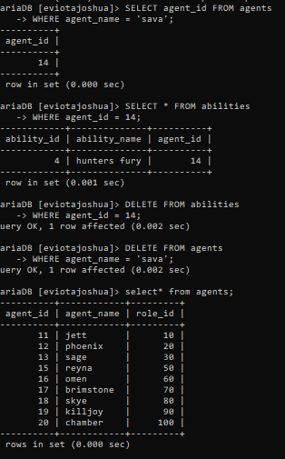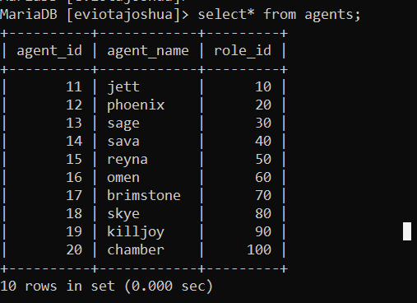I DELETE THE AGENT_ID 14 SAVA

CASCADING

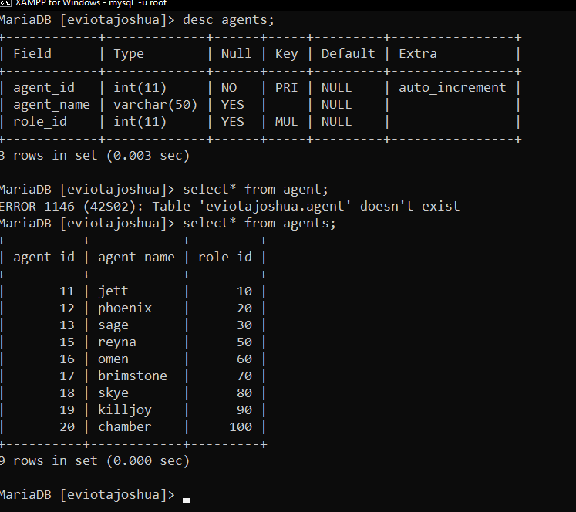“Good day, Ma'am. I didn’t use a cascading command because it was already set up in the database. This means that when I delete or update a row in the main table (agents), the related rows in the other table (abilities) are automatically deleted or updated."